Type the Title of Your Paper Capitalize First Letter (TN Roman 17pt)
First Author^{1*}, Second Author², Third Author³, ... (TN Roman 13pt)
^{1,2}FirstSecond authors(s) affiliation, City, Country
³Third author affiliation, City, Country
*Corresponding author email: author@institute.xxx
Abstract (TN Roman 10pt)
The abstract should summarize the context, content and conclusions of the paper in less than 200-300 words. It should not contain any references or displayed equations. Typeset the abstract in 10pt Times Roman. A maximum of 4-6 key words or phrases must be given that will be useful for retrieval and indexing. The key words must be separated by commas and should not include acronyms.

Keywords: Mathematics, instructions for authors, manuscript template (TN Roman 10pt)

- Introduction (TN Roman 12pt)
The text is to be typeset in 11 pt Times Roman, single spaced. The Introduction should argue the case for the study, outlining only essential background, and should not include the findings or the conclusions. It should not be a review of the subject area, but should finish with a clear statement of the question being addressed.
- Literature Review (TN Roman 12pt)
The text is to be typeset in 11 pt Times Roman, single spaced etc.
- Materials and Methods (TN Roman 12pt)
  - Materials (TN Roman 11pt)
Materialas including: object, location, data & informations, and tolls used in data analysis. (TN Roman 11pt)
  - Methods
Methods include: the stages and formulas that are used in data analysis, arranged sequentially step by step.
    - Structure
Research articles should be divided into the sections listed below. Principal sections should be numbered consecutively (1. Introduction, 2. Materials and methods, etc.) and subsections should be numbered 1.1., 1.2., etc. Do not number the Acknowledgements or References sections.
Manuscripts must be written in English. Contributors who are not native English speakers are strongly advised to ensure that a colleague fluent in the English language or a professional language editor has reviewed their manuscript. Concise English without jargon should be used. Repetitive use of long sentences and passive voice should be avoided. It is strongly recommended that the text be run through computer spelling and grammar programs. Either British or American spelling is acceptable but must be consistent throughout.
    - Formula / Equation
Insert common mathematical equiations or build up your own equations using a library of math symbols. Variables and parameters must be typed in italics, while symbols of vectors or matrices are typed upright and bolded. All formulas or equations to be used in subsequent analyzes, must be numbered in sequence, for example (1), (2), etc. For example as follows:
. (1)
    - Tables
All tables should be numbered with Arabic numerals. Headings should be placed above tables, left justified. Leave one line space between the heading and the table. Only horizontal lines should be used within a table, to distinguish the column headings from the body of the table, and immediately above and below the table. Tables must be embedded into the text and not supplied separately. Table 1 below is an example which authors may find useful.
Table 1: An example of a table (TN Roman 11pt)
An example of a column heading | Column A (t) | Column B (T)
And an entry | 1 | 2
And another entry | 3 | 4
And another entry | 5 | 6
    - Construction of references
Organization and citation of the bibliography are made in American Psychological Association (APA) style. Some examples of how your references should be listed are given at the end of this template in the ‘References’ section, which will allow you to assemble your reference list according to the correct format and font size.
- Results and Discussion
All figures should be numbered with Arabic numerals (1,2,...n). All photographs, schemas, graphs and diagrams are to be referred to as figures. Line drawings should be good quality scans or true electronic output. Low-quality scans are not acceptable. Figures must be embedded into the text and not supplied separately. Lettering and symbols should be clearly defined either in the caption or in a legend provided as part of the figure. Figure is center, as shown Figure 1 and cited in the manuscript.
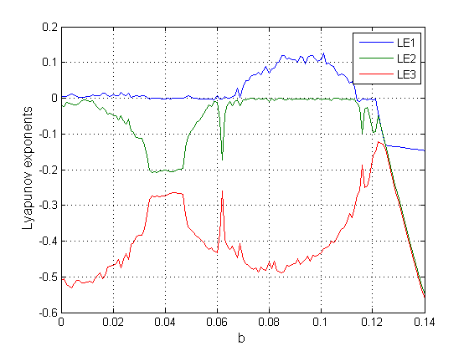
Figure 1: xxxx
- Conclussion
Explain what has been done, and draw conclusions in accordance with the objectives of the research that has been determined. The conclusions are delivered narratively, do not contain equations, tables, and figures.
Acknowledgments
Acknowledgments (if any) need to be delivered if there are institutions or individuals who have an important role to support the implementation of research and publications conducted.
References
The main references are international journals and proceedings. All references should be to the most pertinent and up-to-date sources. References are written in APA style. Please use a consistent format for references – see examples below (10 pt):

Akgul, A., Calgan, H., Koyuncu, I., Pehlivan, I., & Istanbullu, A. (2016). Chaos-based engineering applications with a 3D chaotic system without equilibrium points. Nonlinear dynamics, 84(2), 481-495.
Alligood, K. T., Sauer, T. D. and Yorke, J. A. (1996). Chaos: An Introduction to Dynamical Systems. New York: Springer-Verlag.
Anishchenko, V. S., & Strelkova, G. I. (1997, August). Attractors of dynamical systems. In 1997 1st International Conference, Control of Oscillations and Chaos Proceedings (Cat. No. 97TH8329) (Vol. 3, pp. 498-503). IEEE.

